Study guide for test 1 part 2
Fill out the Bucky the Badger chart
points | score | Total pushups
7 | 7 | 7
3 | 10 | 17
7 | 17 | 34
7 | 24 | 58
7 | 31 | 89

- James is driving to his basketball tryouts and notices that his gas tank is getting close to empty. He is driving 75 MPH and it should take him 1 hour and 30 minutes to get to his exit. James car gets 17 miles per gallon on the highway. Gas is currently $2.35 a gallon.

- How fast is James going? 75MPH

- How far will he go in 1 hour? 75miles

- How far will he go in 30 minutes? 37.5 miles

- How far will he go in 1 hour 30 minutes? 112.5 miles

- Using one gallon of gas, how far will he go? 17miles
- About how many gallons does he need to get to the gas station? 6.62 gallons

- If gas cost $2.35 per gallon, about how much will James spend? $15.56

- If it costs$2.35 to travel 17 miles, how much will James spend to travel one mile on the Freeway? 14 cents

- The students in Mr. Sanchez’s class are converting distances measured in miles to kilometers. To estimate the number of kilometers, Abby takes the number of miles, doubles it, then subtracts 20% of the result. Renato first divides the number of miles by 5 and the multiplies the result by 8.

- Write an algebraic expression for each method.
Abby- 2m-.20(2m)
Renato- 8(m/5)

- Use your answer to part (a) to decide if the two methods give the same answer.

Yes they do

18.
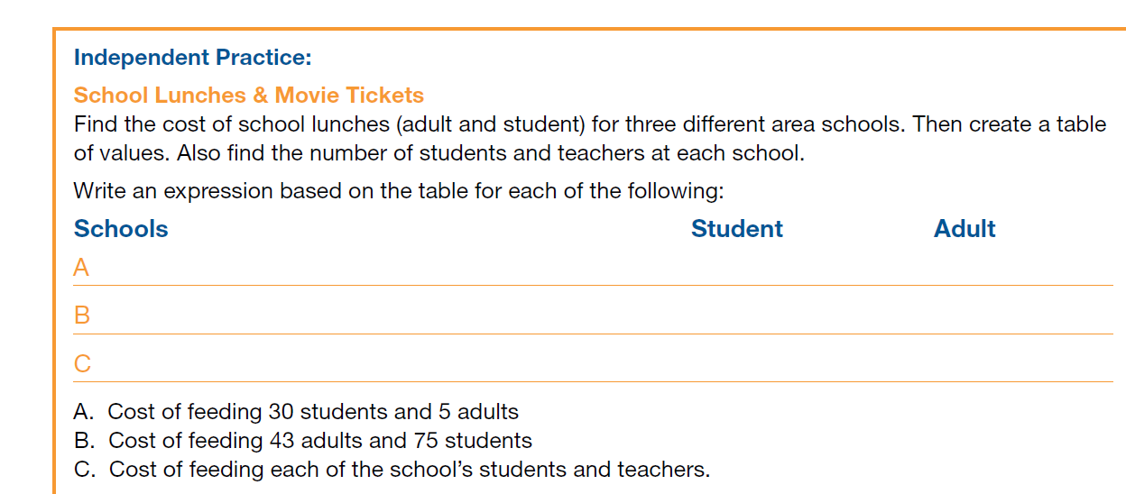
- 30s+5a= 75 for students, 15 for adults
- 43a+75s= 187.5 for students, 129 for adults
- 48a+105s= 262.5 for students, 144 for adults
- Find movie tickets prices at five different cities around the country. Include adult, children, matinee and regular shows.
City Adult matinee Adult regular Child matinee Child regular
A Atlanta $9.84 $10.45 $ 7.95 $ 9.00

B Dallas $4.00 $5.00 $3.00 $3.50

C L.A $15.00 $17.00 $12.00 $14.00

A. You have $100. In which city can you take the most adults and children to the matinee, if for every
two children there is an adult?
Dallas

- What is the cost of four children and three adults for a matinee in each of the three cities?

Atlanta= 61.32
Dallas=24
LA= 93

- Which city has the best deal for a family of five to attend the movies?
Dallas

- Suppose p and q represent the price (in dollars) of a 64GB and a 32GB smartphone, respectively,where p > q. Interpret each of the expressions in terms of money and smartphones. Then, if possible,determine which of the expressions in each pair is larger.

- p+q and 2q
P+Q

- p+0.08p and q+0.08q
P+0.08P

- 600-p and 600-q
600-q

